Fundamentals of Marketing

Exam 3 – Spring 2013

*The More the Merrier*

*Burger King’s Big Mis-step*

*Messing with Fate*.

Random Info:

**Retail** – All the activities associated with selling, renting, and providing goods and services to ultimate consumers for personal, family, or household use.

**Public Relations** – A form of communication management that seeks to influence the image of an organization and its products and services.

**Marketing** – Marketing is an organization function and a set of processes for creating, communicating, and delivering value to customers and for managing customer relations in a way that benefit the organization and its stakeholders.

**Chapter 16: Retailing**

* **Classifying retail outlets**
  + **Forms of Ownership**
    - **Independent Retailer** – Independent business owned by an individual.
    - **Corporate Chain** – Multiple outlets under the same common ownership.
    - **Contractual Systems** – Independently owned store that band together and act like a chain.
  + **Levels of Service**
    - **Self Service** – Customer provides many functions and little is provided by the outlet.
    - **Limited Service** – The retailer provides some services but not others. E.g. Target.
    - **Full Service** – Provide many services to the customer. E.g. Nordstrom
  + **Merchandise Line**
    - **Depth of Line** – Stores that carry a considerable assortments of a related line of items. Specialty stores like Sephora.
    - **Breadth of Line** – Stores carry a broad product line, with limited depth. General merchandise stores like Walmart.
* **Retail Life Cycle** 
  + The process of growth an decline that retail outlets experience.
  + 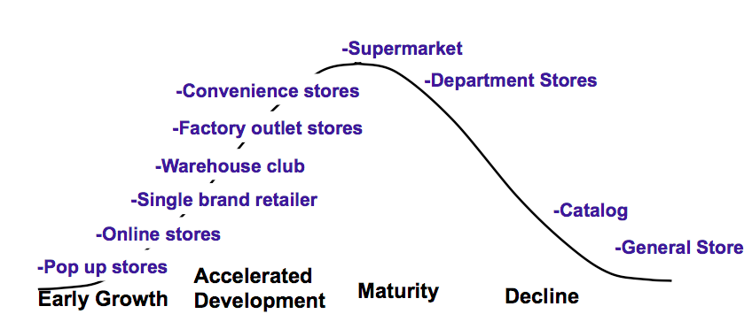

**Chapter 17: Integrated Marketing Communications**

* **Promotional Mix (Inform, Persuade, & Remind): Communication Tools**
  + **Advertising** – Any paid form of non-personal communication.
  + **Personal Selling** – Two-way flow of communication between a buyer and seller.
  + **Sales Promotion** – Short-term inducement of value offered to around interest in buying a product.
  + **Public Relations** – Communication management that seeks to influence feelings, opinions, or beliefs held by stakeholders.
    - **Publicity:** Non-personal, indirectly paid presentation of an organizational product.
  + **Direct Marketing** – Direct communication to generate a response in the form of an order, request for further information, or visit to a retail outlet.
    - **Value:** Direct orders, lead generation, and traffic generation.
* **Integrated Marketing Communications (IMC)**
  + Designing marketing communications programs that coordinate all promotional activities to provide a consistent message across all audiences.
  + **Three Step Promotional Decision Process**
    - **Developing**
      * *Who* is the target audience?
      * *What* are the (1) promotional objectives, (2) budgeted monies, and (3) kinds of promotion to use?
      * *When* should the promotion be run?
      * *Where* should the promotion be run?
    - **Executing**
      * Pretest the promotion
      * Carry out the promotion
    - **Evaluating**
      * Posttest the promotion
      * Make needed changes
* Communication Process (6 Elements)
  + Communication is the process of conveying a message to others.
  + 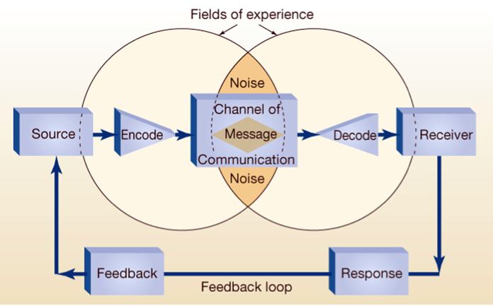
  + **Forming The Promotional Mix**
    - **Issue 1: The balance of the elements must be determined:**
      * Target Audience
      * Stage of the product life cycle
      * Product Characteristics – Complexity, risk, and ancillary services.
    - **Stage of the buying decision**
      * Pre-purchase, purchase, and post-purchase stages
    - **Channel Strategies**
      * Push v. Pull
    - **Issue 2:**
      * Planning process needs to ensure promotional elements across different departments result in a consistent promotional effort.

**Chapter 18: Advertising, Sales Promotion, and Public Relations**

* **Product advertisements**
  + **Pioneering (Or Informational)**
    - Used in introductory stages of product life cycle.
  + **Competitive (Or Persuasive)**
    - Promotes the specific brand’s features or benefits.
  + **Reminder**
    - Used to reinforce previous knowledge of a product.
* **Institutional advertisements (advocacy, pioneer, competitive, reminder)**
  + **Advocacy Advertisements**
    - State position of a company on an issue.
  + **Pioneer**
    - Announcements about what a company is, what it can do or where it was located.
  + **Competitive Institutional**
    - Promotes the advantages of one product class over another.
  + **Reminder Institutional**
    - Brings company’s name to the attention of a target market.
* **5 steps of developing advertising program** 
  + **Identify the target audience**
  + **Specify advertising objectives**
  + **Setting the advertising budget**
  + **Designing the advertising**
  + **Message content**
    - **Fear Appeal** – Suggests that consumer can avoid negative experience by some change in behavior.
    - **Sex Appeal** – Suggest the company will increase the attractiveness of the user.
    - **Humor Appeal** – Product is more fun or exciting than competitors’
* **Know the basic terms**
  + **Reach** – Number of different people that are exposed to message.
  + **Rating** - % of households that are tuned to a particular TV show.
  + **Frequency** – Average # of times a person in the target audience is exposed to an ad.
  + **Gross Rating Points (GRP)** – Reach (x) Frequency.
  + **CPM** – Cost of reaching 1,000 individuals with an advertising message in a given medium.
* **Media Alternatives** 
  + **Television**
    - **Pros**
      * Communicates with sight, sound, & motion
      * Wide Reach
    - **Cons**
      * Cost
      * Wasted Coverage – People outside the target market will see the advertisement
    - **Infomercials** – Program-length adverts that educate potential custom on product.
  + **Radio**
    - **Pros**
      * Segmented medium
    - **Cons**
      * Limited use because most products must be seen
  + **Magazine**
    - **Pros**
      * Segmented medium (e.g. Runner’s World, Economist, Teen Vogue)
    - **Cons**
      * Costs, infrequency of publication
  + **Outdoor (E.g. Billboards, transit advertising)**
    - **Pros**
      * Good reach and frequency, low cost.
    - **Cons**
      * At heavy travel times it’s hard to read, easy to ignore, relatively non-segmented.
  + **Newspaper**
    - **Pros**
      * Good reach, frequency of publication – adverts remain current; ability to target
    - **Cons**
      * Lack of creative options, fewer and fewer readers
  + **Yellow Pages**
    - **Pros**
      * High use, wide reach, available 24/7, long lifespan
    - **Cons**
      * Outdated; consuming audience is MUCH older and less savvy
  + **Internet & Interactive Media**
    - **Pros**
      * Can have audio & video, segmented medium; easy to measure response; easy to target specific targets
    - **Cons**
      * Consumers tune out or avoid messaging; fragmented audience
* **Scheduling the advertising (continuous, flighting, pulse)**
  + **Continuous** – Advertising is run at continuous or steady schedule.
  + **Flighting** – Periods of advertising are scheduled between periods of no advertising.
  + **Pulse** – Flighting schedule combined with a continuous schedule because of increases in demand, heavy period of promotion or introduction of new product.
* **Steps of Advertising Program**
  + **Pretesting the Advertisement**
    - Conducted prior to placing adverts
  + **Evaluating the Advertising Program**
    - Posttesting – Determine if adverts accomplished purpose
      * **Aided Recall** – Ask if they recall specific adverts
      * **Unaided Recall** – “What ads do you remember seeing?”
      * **Attitude Tests** – Respondents are asked attitude questions about product
      * **Inquiry Tests** – Measure how many inquires are generated by ad
      * **Sales Tests** – Controlled experiments (TV v. Radio) – manipulating advertising and see what increases sales
  + Change based on testing

**Chapter 21: Interactive and Multichannel Marketing**

* **Internet Marketing** 
  + **Marketplace vs. Marketspace**
    - Marketers believe value creation is great in the digital marketplace.
  + **Marketspace expands utility to consumers**
    - Time & Place – Operating hours and geographical constraints do not exist online.
    - Possession – Getting the product to the consumer is accelerated.
    - Form – Consumers can voice requirements and products can be customized to their needs.
  + **Interactivity & Individuality**
    - **Customer & Firm Interact** – Customers are treated like individuals and have a part in the product creation and delivery process.
      * **Choiceboards** – Customers choose options
      * **Personalization** – Creating content on marketers website.
  + **Lifestyle Segments**
    - **Click & Mortar** – Women who browse online but buy in store
    - **Hunter Gatherers** – Married couples who gather information and compare prices
    - **Brand Loyalists** – Regularly visit their favorite sites – spent the most $ online
    - **Time Sensitive Materialists** – Use the internet as a convenience to buy search goods
    - **Hooked, Online, & Single** – Young, affluent use internet to bank, play – spend the most time online.
    - **Ebivalent Newbies** – Relatively new users who don’t spend money but seek info
* **Cross-Channel Shopper**
  + An online shopper who researches online and purchases at store.
  + Important that retailer / brand has presence across multiple channels that are mutually reinforcing.
* **5 Cs about why consumers by online: convenience, cost, control…** 
  + **Convenience** – Bots, 8 second rule
  + **Cost** – Dynamic Pricing
  + **Choice** – Many choices & assistance
  + **Customization** – My Yahoo! Choiceboards
  + **Communication** – Web communities, blogs, viral marketing
  + **Control** – Empowered to seek and evaluate.
* **Marketplace vs. marketspace** 
  + In marketspace (vs. marketplace) direct, on-demand information is possible from marketers anywhere to customers anywhere at any time.

**Cumulative Component:**

**Chapter 1:**

* **Four Ps**
  + **Product** – Commodities, services, and ideas.
  + **Place** – Retail stores, popups, etc.
  + **Price** – Exchanging money, trading/bartering, or time.
  + **Promotion** – Advertising, guerilla marketing, PR, and product placement.
* **Need vs. Want**
  + **Need** – When a person feels deprived of basic necessities
  + **Want** – A need that is shaped by a person’s knowledge, culture, and personality.

**Chapter 2:**

* **SWOT analysis**
  + **Strengths** – Build on key competencies
  + **Weaknesses** – Correct glaring problems
  + **Opportunities** – Exploit significant opportunities
  + **Threats** – Avoid disaster
* **Business Portfolio analysis**
  + **Star** – Market leaders, fast growing, require investment
  + **Cash Cow** – Profitable products, generate more cash than needed for share maintenance, and slows sales growth.
  + **Problem Child / Question Market** – Rapid growth, poor profit margins, enormous demand for cash.
  + **Dog** – Cost disadvantage, markets not growing.

|  |  |
| --- | --- |
| * + Star | * + Problem Child / Question Market |
| * + Cash Cow | * + Dog |

**Chapter 9:**

* **Market Segment**
  + **Market Segmentation –** A group of customers with common needs and who will respond similarly to market actions.
  + **When it is used**
    - **One Product, Multiple Segments –** McDonalds. They target children and youth.
    - **Multiple Products, Multiple Segments –** Lays, Doritos, Fritos, and Sun Chips.
    - **Segments of One –** Mass customization. YouBar.
  + **recognize factors used to segment and target consumer markets**
  + **How marketers position their products in the marketplace**
    - The place an offering occupies in consumers’ minds on important attributes relative to competing products.
    - **Head to Head** – Competing directly with competitors on similar product attributes.
    - **Differentiation** – Seeking a less competitive or different market niche.
  + **Make sure to be aware of the ways to segment consumer markets**
    - **Customer characteristics**
    - **Geographic**
    - **Demographic**
    - **Psychographic**
  + **Buying situations**
    - **Benefits sought**
    - **patronage**

**Chapter 11:**

* **Product lifecycle (what happens at each stage).** 
  + **Introduction** – Occurs when product is first introduced. Slow sales growth, minimal profit.
  + **Growth** – Rapid increases in sales.
  + **Maturity** – Slowing of total industry sales & profits decline.
  + **Decline** – Sales and profits decline.
* **Brand equity**
  + The added value a brand name gives to a product beyond the functional benefits provided.

**Chapter 13:**

* **Final Price = list Price – (incentives + allowances) + extra fees**
* **Fixed vs variable costs**
* **Marginal analysis**
  + Incremental costs against incremental revenues.
* **Breakeven point (equation)**
  + BEP = (Fixed Cost) / (Unit Price – Unit Variable Cost)
* **Elastic vs. inelastic vs. unitary demand**
  + **Price Elasticity of Demand** = (% Change in Quantity Demanded) / % Change in Price
  + **Elastic Demand** – When 1% decrease in price produces more than 1% increase in quantity.
  + **Inelastic Demand** – When 1% decrease in price produces less than 1% increase in quantity. Actually decreases sales revenue.
  + **Unitary Demand** – When % change in price is identical to % change in quantity demanded. Sales revenue remains same.

**Chapter 15:**

* **Direct vs. Indirect channel**
  + **Direct:** Producer -> Consumer
  + **Indirect:** Producer -> Agent -> Wholesaler -> Retailer -> Consumer
* **Channel choice (costs vs. benefits to direct vs. indirect channels)**
* **Dual distribution vs. strategic alliance vs. direct distribution**
  + **Dual Distribution –** Using two or more different types of channels to reach different buyers with the same basic product.
  + **Strategic Alliance –** One firm’s marketing channel is used to sell another firm’s product. E.g. Best Buys 2013 Super Bowl Ad.
  + **Direct Distribution –** E.g. Etsy